Computer networks

**Lab activity – 7**

**Name :** N.V.M.Sumanth

**Reg no :** 192111449

**Faculty :** Dr. S. Ramesh

**Course code :** CSA0786 computer networks for wanet applications

**Lab activity :7**

**Question -**) **Tracer (Distance vector Dynamic Routing using Packet & OSPF.**

**1a)dynamic routing :**

**Step 1 : Take three routers**

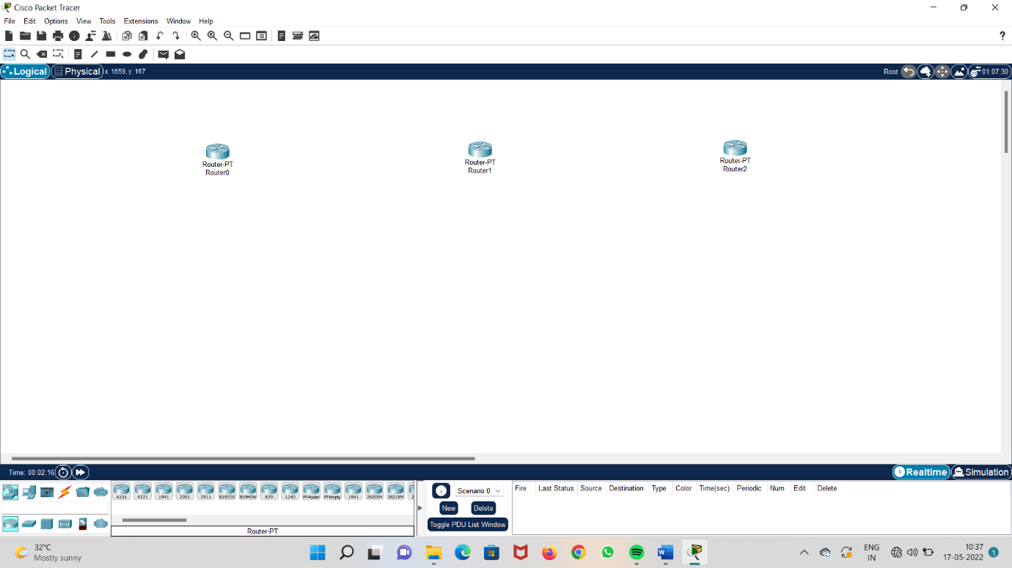

**Step 2 : take three switches**

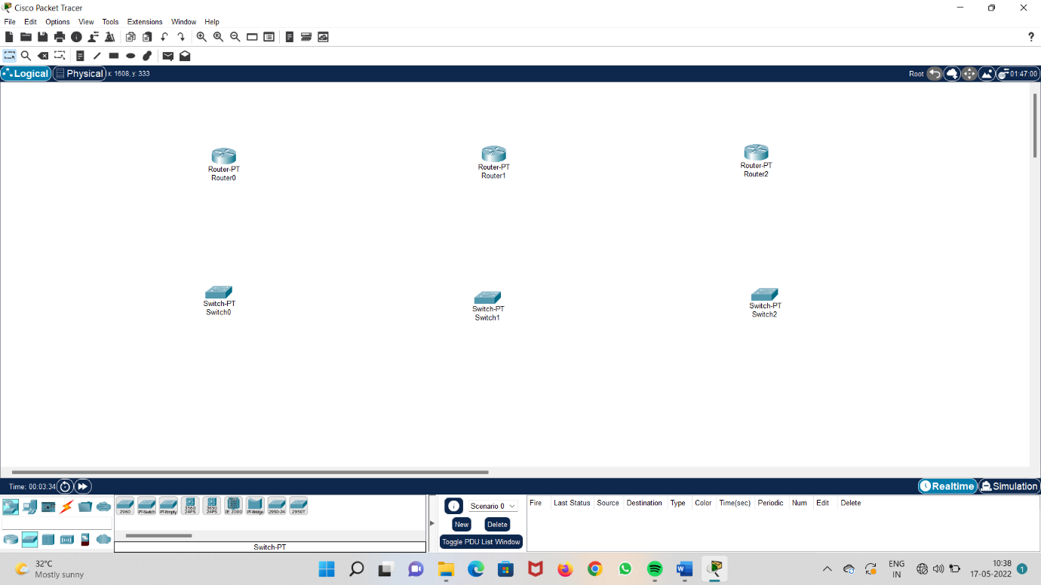

**Step 3 : take three systems**

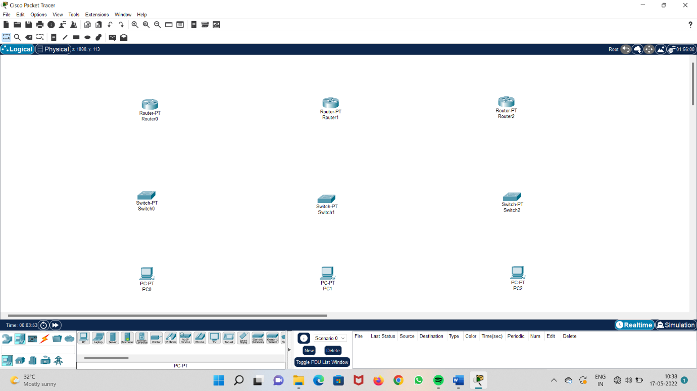

**Step 4 : connect all the routers, switches and systems**

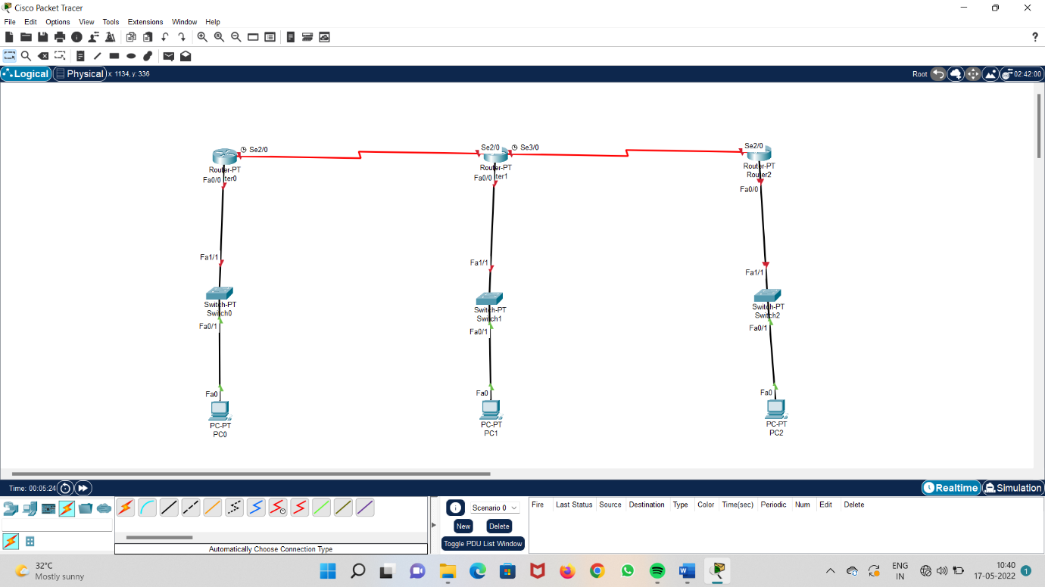

**Step 5 : configure IP address , subnet mask id and default gateway**

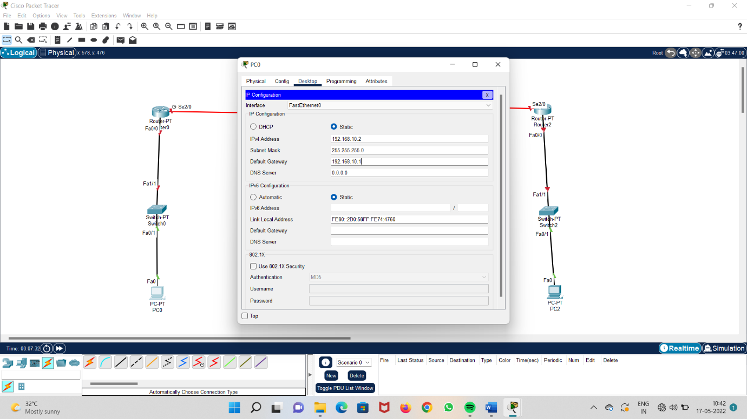

**Step 6 : configure Ip address to fast ethernet and switch on the port**

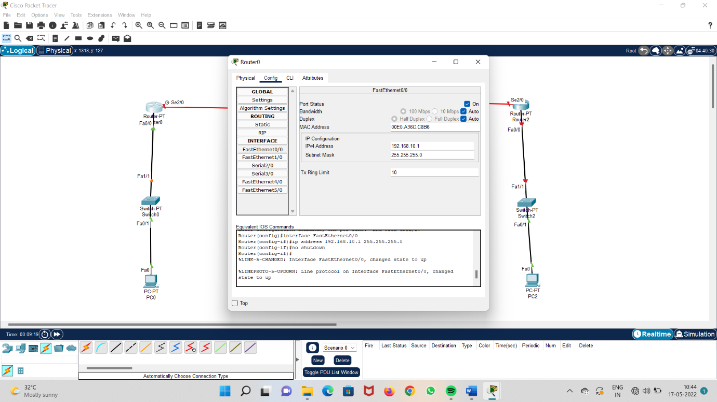

**Step 7 : configure IP address to the serial in configuration and set the clockrate for all the routers**

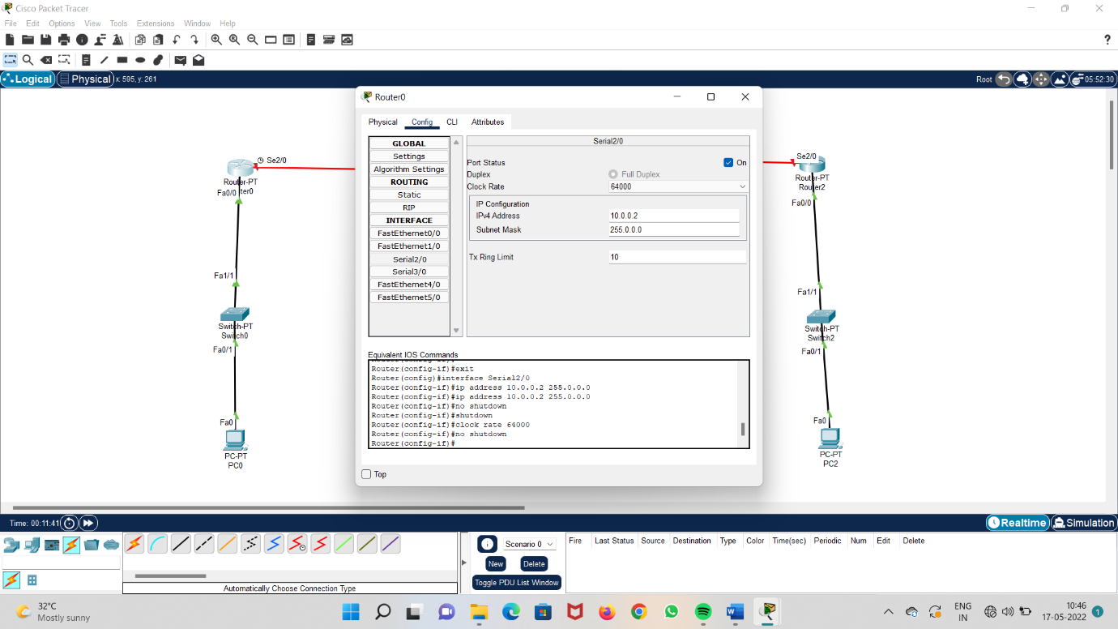

**Step 8 : enter network addresses in RIP routing**

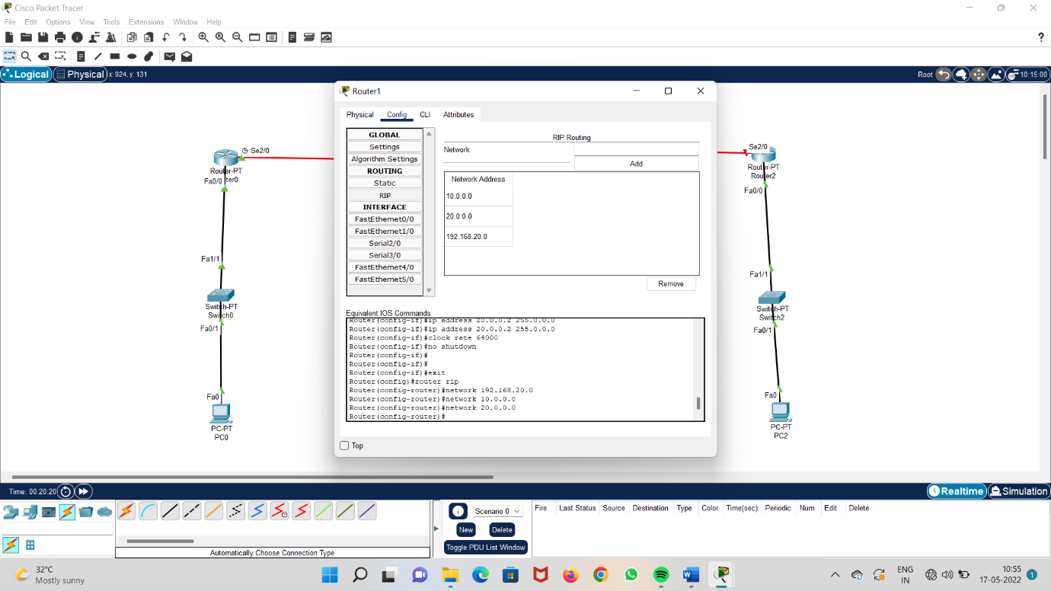

**Step 9 : Run the system and check the acknowledgement**

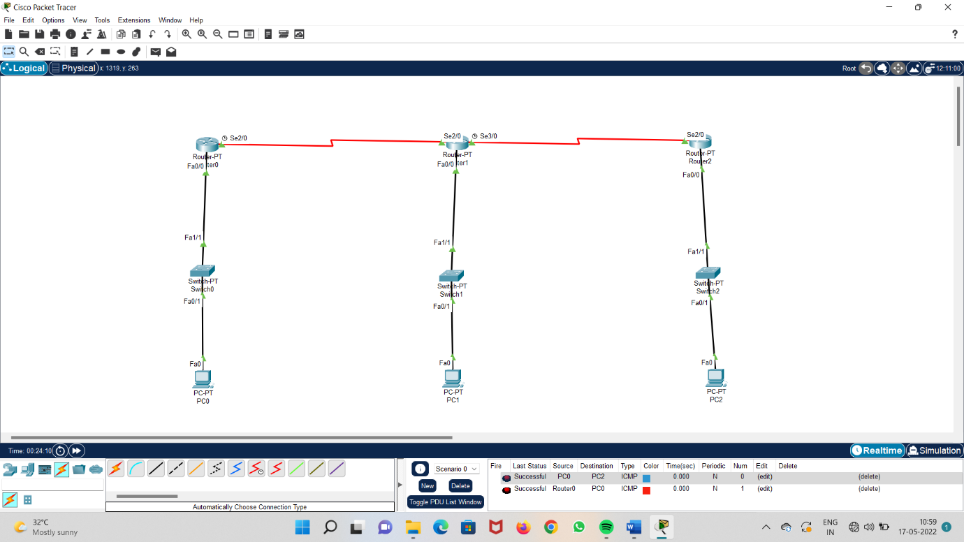

**1b)OSPF**

**Step 1 : take three routers**

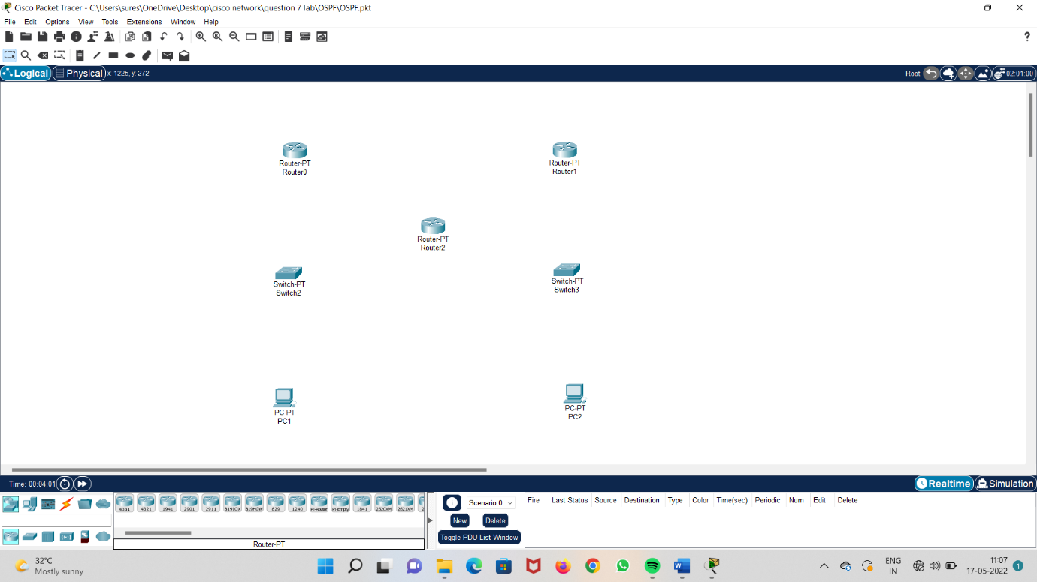

**Step 2 : take two switches**

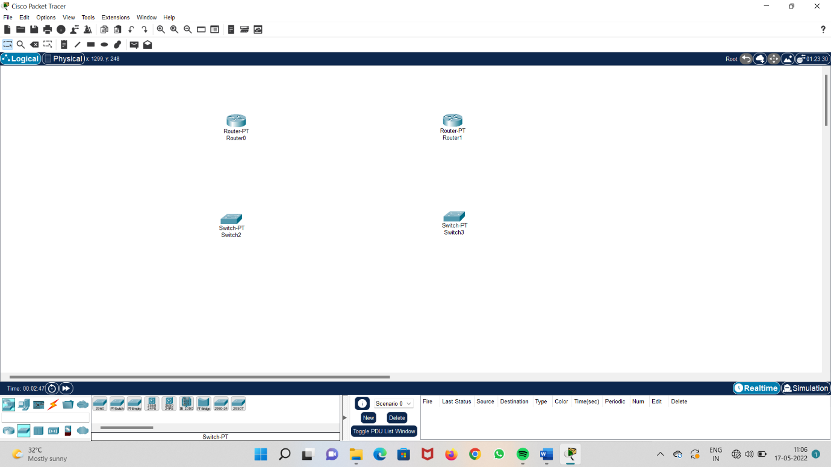

**Step 3 : take two systems**

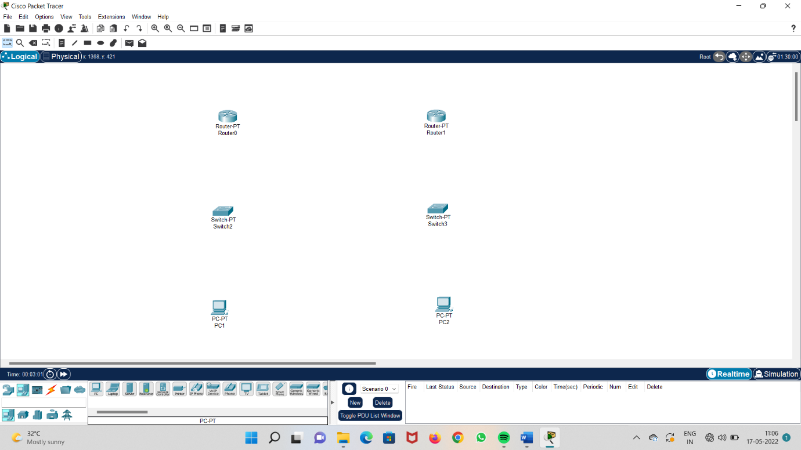

**Step 4 : connect all the routers, switches and systems.**

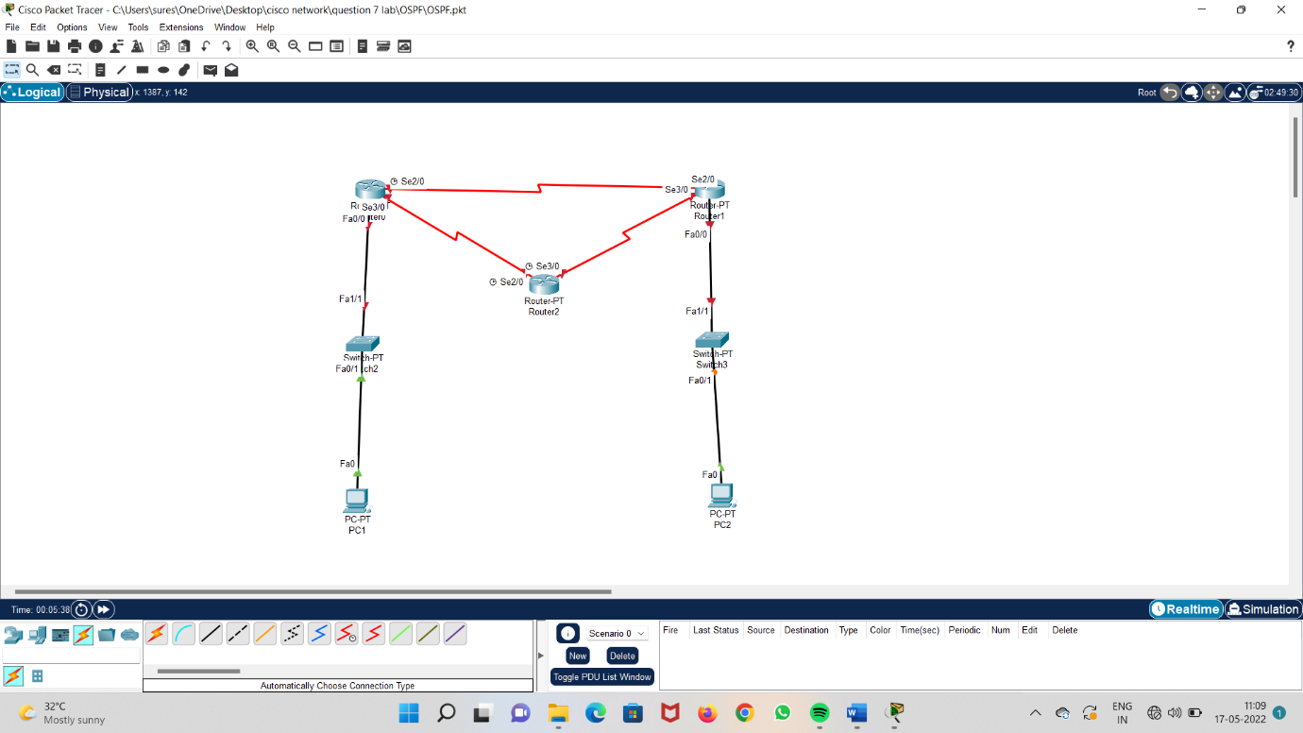

**Step 5 : configure Ip address to all the systems**

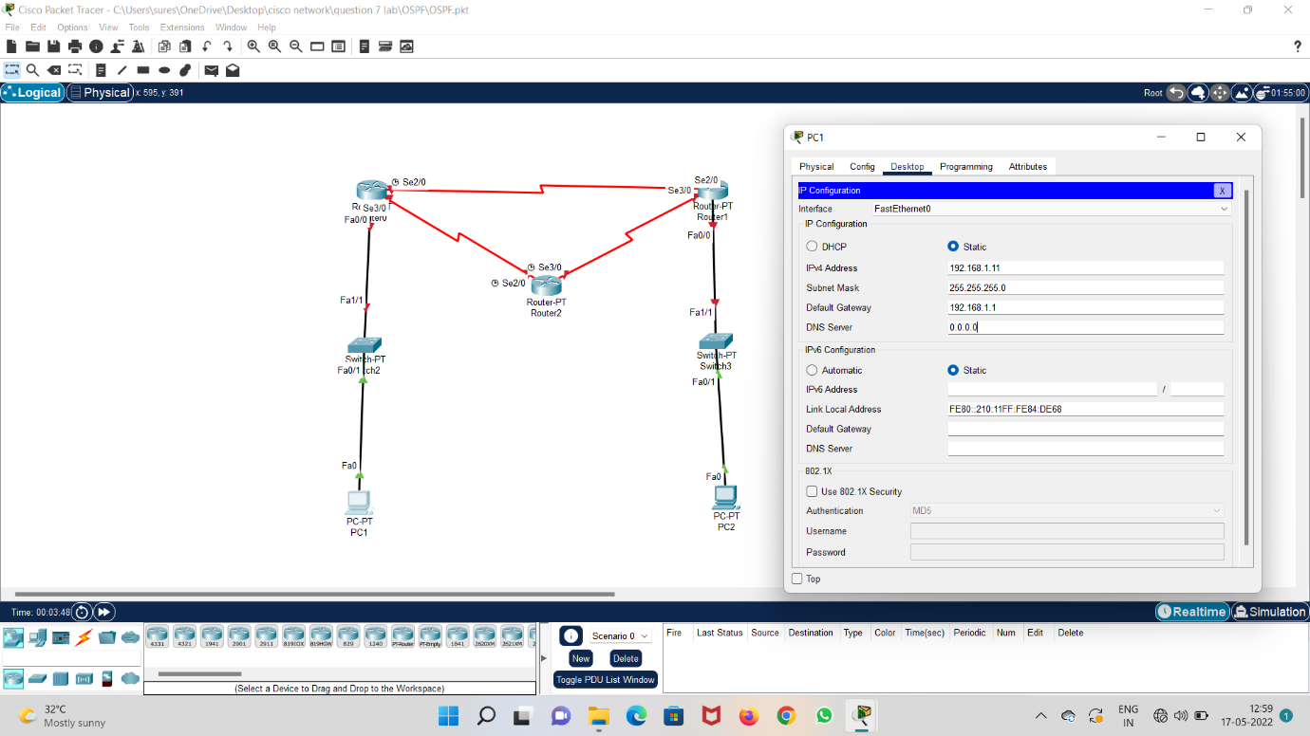

**Step 6 : configure Ip address in fast etherner 0/0 in router 0 and switch on port**

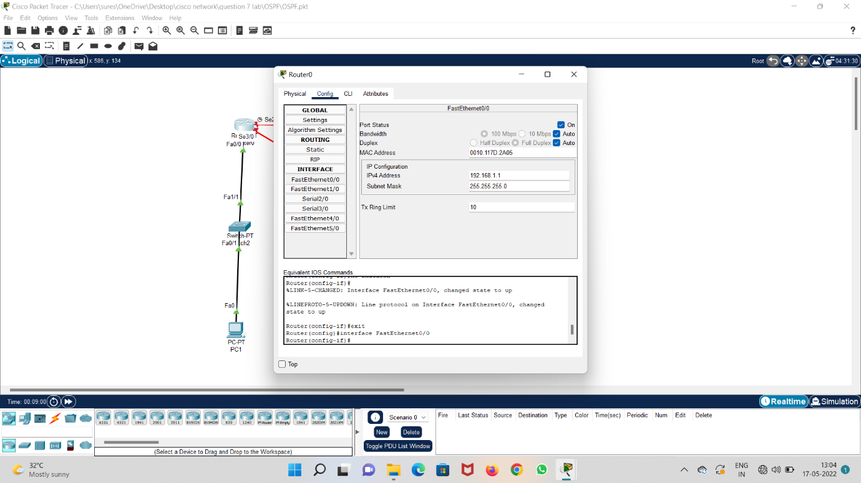

**Step 7 : configure IP address in serial 2/0 in router 2 ,set clockrate and switch on the port**

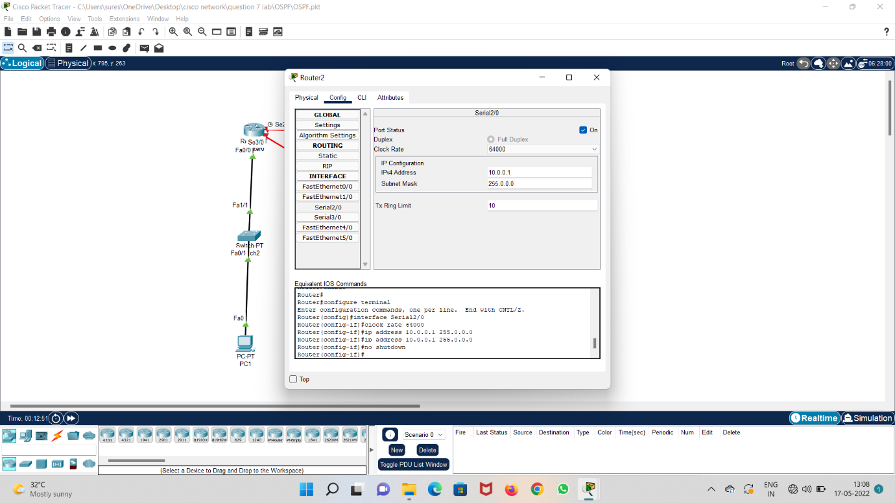

**Step 8 : repeat the previous step in serial 3/0 and 2/0 of router 1**

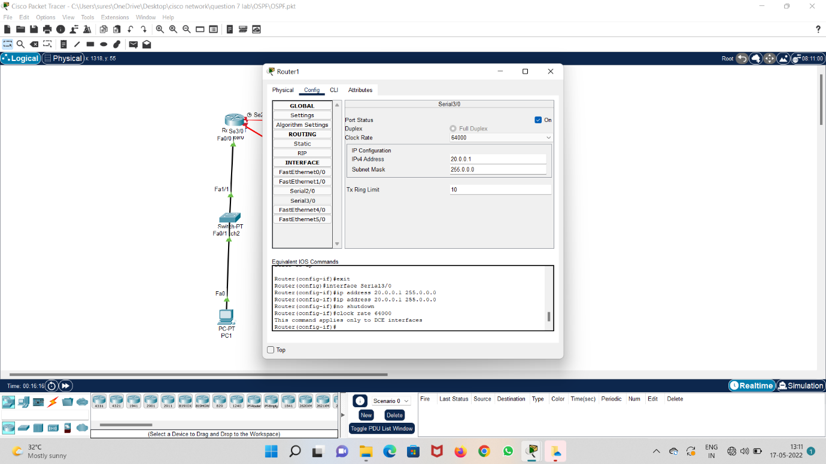

**Step 9 : run the system and check acknowledgement**

